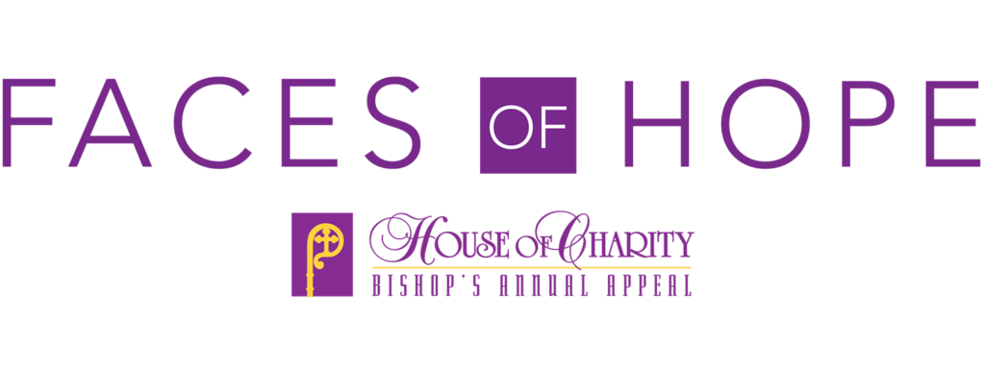

I would like to Support the House of Charity – Bishop’s Annual Appeal with:
(Please check all applicable boxes for Gift and Payment Information)

- A One-time gift of: | $_______ | Paid by: (Please circle) Check / Credit Card, OR,
- A Pledge to gift a total of: | $_______
- With a down payment of: | $_______ | & remaining Pledge Balance of: $________, OR,
  - Without a down payment.

My Pledge Balance will be paid in: | _______ | Monthly Installment Payments of: $__________
Total or Down Payment paid by check #: | _______ | with the check dated: _____/_____/_____

- Use my credit card for payment of my one-time gift or monthly installment payments. | Type: (Please circle)  MasterCard, Visa, Discover, Amex
Cardholder Name: ______________________________ | Expiration: _____________________
Card #: ________________________________________ | Security Code: ______________, OR,
- Use my included voided check to direct debit monthly installment payments.

Donor Information:
Name:
Address:
City: | State: | Zip:
Phone # with Area Code:
Email Address:
Parish:
Signature: | Date:

